Linear Spaces

A point in n-dimensional space, denoted R^{n}, has coordinates (x₁, x₂, …, x_{n}).

R^{n} = {( x₁, x₂, …, x_{n}): x₁, x₂, …, x_{n} R}.

If M = 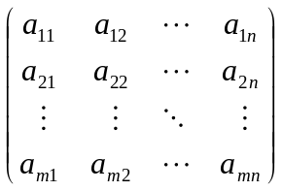 and 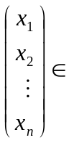R^{n},

then T: R^{n}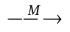R^{m} is a linear transformation from R^{n} to R^{m}.

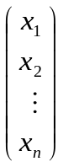= 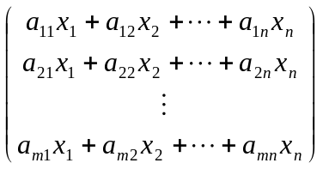

= 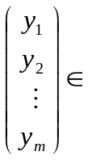R^{m}.

Eg. M = 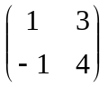 and 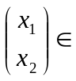R²

M = 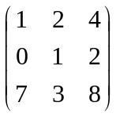 and 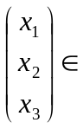R³

M = 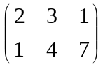 and R³

M = 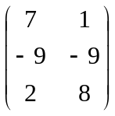 and R²

M = 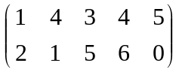 and 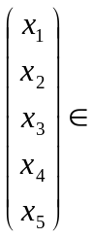R⁵

M = 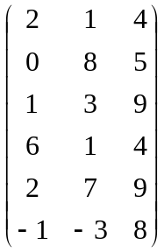 and R³

A diagonal matrix is a square matrix in which every entry which is not on the main diagonal is zero:
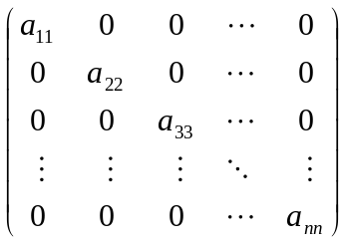

An upper triangular matrix is a square matrix of the form:
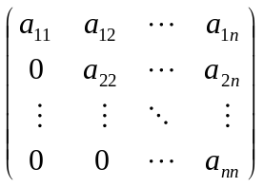

A lower triangular matrix is a square matrix of the form:
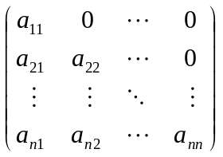

If A is a matrix of size m n
A =
the transpose of A , A^{T}, is the n m matrix obtained by interchanging the rows and columns of A.
Eg. If A = 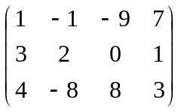 x 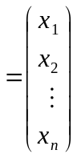
A^{T} = 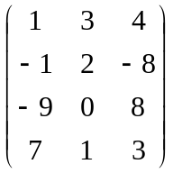 x^{T} = (x₁, x₂, …, x_{n})
A system of linear equations in the n variables x₁, x₂, …, x_{n} has the form:

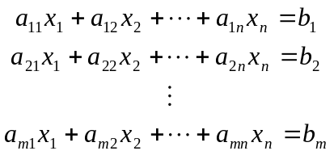

The system is said to be homogeneous if 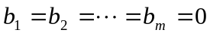 and not homogeneous if one or more of the constants b₁, b₂, …, b_{m} are not zero.

Eg.

The system represented in matrix form is

= 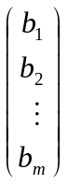 or Ax = b

if A = , x = and b = .

If A is a square matrix and A⁻¹ exists
∴ A⁻¹(Ax) = A⁻¹(b)

(A⁻¹A)x = A⁻¹b

Ix = A⁻¹b

x = A⁻¹b

and x has the unique solution A⁻¹b. If A⁻¹ does not exist, Ax = b has either no solution or
infinitely many solutions.

Since every vector can be considered a matrix having 1 column the set of vectors in
R^{n} : {x : x ∈ R^{n}} is a subset of the set of matrices having n columns : {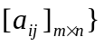.

If any set of objects V satisfies the following conditions then V is called a vector space under the operations of addition and scalar multiplication.

1. If a and b are objects in V then a + b is an object in V.
2. a + b = b + a.
3. If a, b and c are objects in V then a + (b + c) = (a + b) + c
4. There exists an object 0 in V such that a + 0 = 0 + a = a for all a in V.
0 is called the zero vector.
5. For each object a in V there is an object –a in V called the negative of a such that
a + (-a) = (-a) + a = 0.
6. If a is any object in V and k is any scalar then ka is an object in V.
7. k(a + b) = ka + kb.
8. (k + l) a = ka + la for any scalars k and l.
9. k(la) = (kl)a.
10. 1u = u.

The set of matrices {satisfies these conditions and forms a vector space.

The set of vectors in R^{n} also satisfies these conditions and forms a vector space.

The set of all real valued functions defined on R^{n} also satisfies these conditions and forms a vector space.

For the system of linear equations

the augmented matrix is the matrix 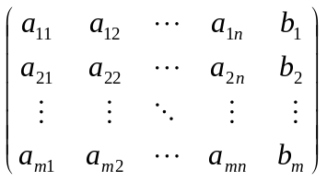

Eg.
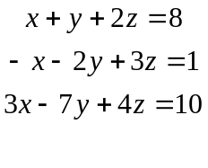

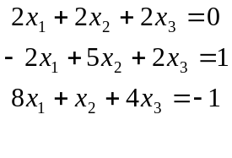

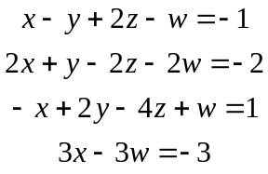

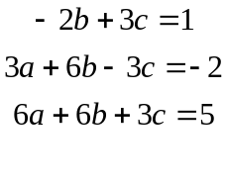

If V is a vector space and W is a subset of V then W is a subspace of V if W itself is a vector space. The set W is a subspace of the vector space V if and only if

1. If a and b are in W, a + b is in W.
2. If k is any scalar and a is a vector in W, ka is in W.

Subspaces of R² Subspaces of R³

{0} = 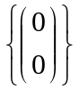 {0} = 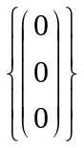
Lines through the origin. Lines through the origin.
Planes through the origin.

If Ax = 0 then the set of solution vectors is a subspace of R^{n}.

Eg. 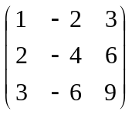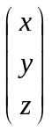 = 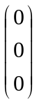

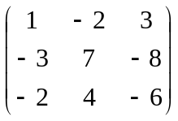 =

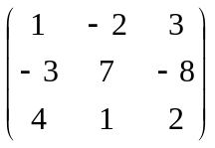 =

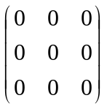 =

The vector w is called a linear combination of the vectors v₁, v₂, …, v_{r} if it can be expressed in the form w = k₁v₁ + k₂v₂ + … + k_{r}v_{r} where k₁, k₂, …, k_{r} are scalars.

Eg. Every vector 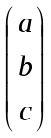 in R³ is expressible as a linear combination of i, j and k since
= a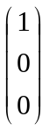 + b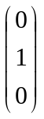 + c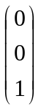

u = 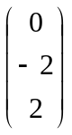 v = 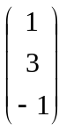

a) 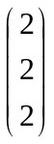

b) 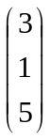

c) 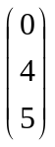

d)

u = 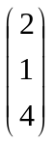, v = 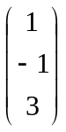, w = 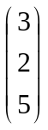

If V is a vector space and v₁, v₂, …, v_{r} are vectors in V, the set of all linear combinations
{k₁v₁ + k₂v₂ + … + k_{r}v_{r}} is a subspace of V.

If v₁, v₂, …, v_{r} are vectors in a vector space V the subspace W of V consisting of all linear combinations of v₁, v₂, …, v_{r}, W = {k₁v₁ + k₂v₂ + … + k_{r}v_{r}} is called the space spanned by v₁, v₂, …, v_{r} and we say that the vectors v₁, v₂, …, v_{r} span W.

Eg. For a vector v, span{v} is the line through the origin determined by v since the line is
the set of all multiples of the vector v.

z
span{v}
y
v
kv
x

For two nonparallel vectors v₁, v₂, span{v₁, v₂} is the plane passing through the
origin determined by the vectors v₁ and v₂ since the plane is the set of all linear
combinations of the vectors v₁ and v₂.

v₁
v₂
span{v₁, v₂}
y
z
x

a) v₁ = , v₂ = 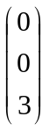, v₃ = 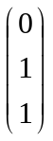

b) v₁ = 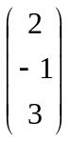, v₂ = 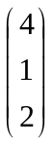, v₃ = 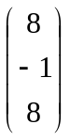

c) v₁ = 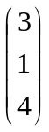, v₂ = 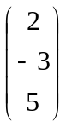, v₃ = 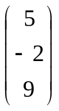, v₄ = 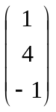

d) v₁ = 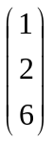, v₂ = 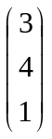, v₃ = 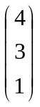, v₄ = 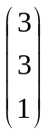

If v₁, v₂, …, v_{r} are vectors then the vector equation k₁v₁ + k₂v₂ + … + k_{r}v_{r} = 0 has the solution k₁ = k₂ = … = k_{r} = 0. If this is the only solution, then the vectors v₁, v₂, …, v_{r} are linearly independent. If there are other solutions, then v₁, v₂, …, v_{r} are linearly dependent.

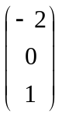, , 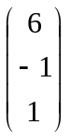, 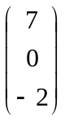

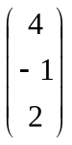, 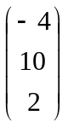 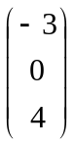, 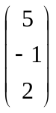, 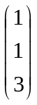

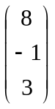, 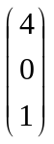

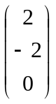, 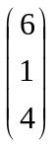, 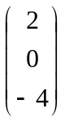

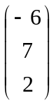, 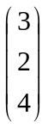,

If V is a vector space and S is a set of vectors in V, S = {v₁, v₂, …, v_{n}}, S is called a basis of V if the vectors in S are linearly independent and S spans V.

Eg. If i = , j = , k =
∴ S = {i, j, k} is a linearly independent set in R³. S also spans R³ since every vector
in R³ can be expressed as = a + b + c.
S is a basis for R³ and is called the standard basis for R³.

The dimension of a vector space V, dim(V) is the number of vectors in a basis for V.
The zero vector space is defined to have dimension 0.

, 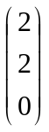, 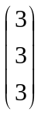

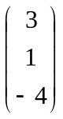, 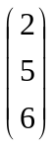, 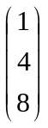

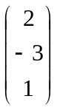, 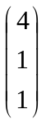, 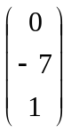

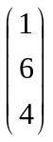, 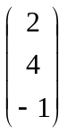, 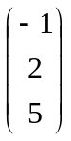

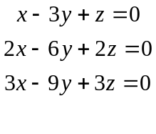

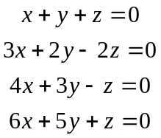

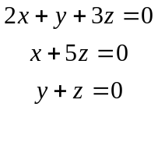

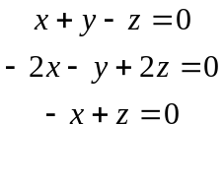

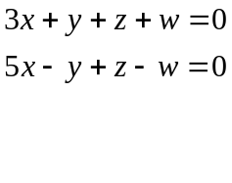

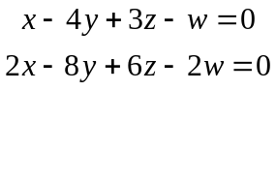

If A =

the vectors r₁ = [a₁₁ a₁₂ … a_{1n}], r₂ = [a₂₁ a₂₂ … a_{2n}], …, r_{m} = [a_{m1} a_{m2} … a_{mn}]
are called the row vectors of A and the vectors

c₁ = 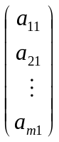, c₂ = 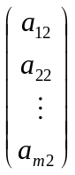, …, c_{n} = 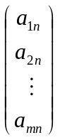 are called the column vectors of A.

The subspace spanned by the row vectors of A is called the row space of A and the subspace spanned by the column vectors is called the column space of A. The solution space of the system Ax = 0 is called the nullspace of A.

If v₁, v₂, …, v_{r} form the basis of the nullspace of A, that is form the solution space of the system Ax = 0 and x₀ is a solution of the inhomogeneous system Ax = b, that is Ax₀ = b then every solution x of Ax = b has the form x = x₀ + c₁v₁ + c₂v₂ + … + c_{r}v_{r}.

The rank of A, denoted rank(A), is the dimension of the row and column space of A.
The nullity of A, denoted nullity(A), is the dimension of the nullspace of A.

Dimension Theorem for matrices.
If A is a matrix of size m × n, A = 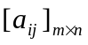,
rank(A) + nullity(A) = n.

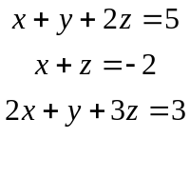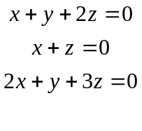

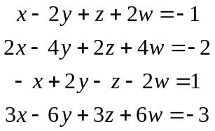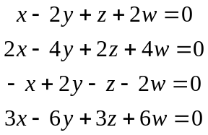

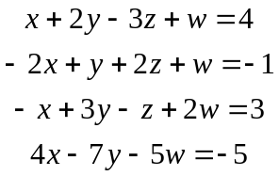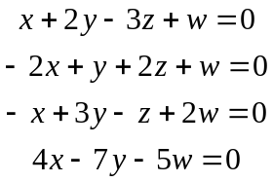

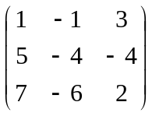

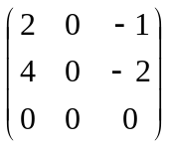

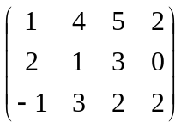

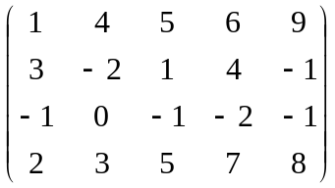

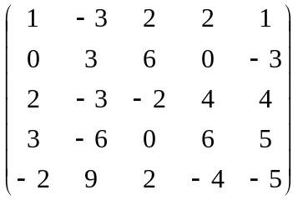

A = 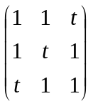

A = 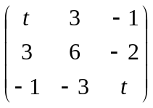

References:
1. Elementary Linear Algebra, 7th Edition
Howard Anton
John Wiley & Sons, Inc.

